Metro Richmond Flying Squad Inc.

2021

Annual Report

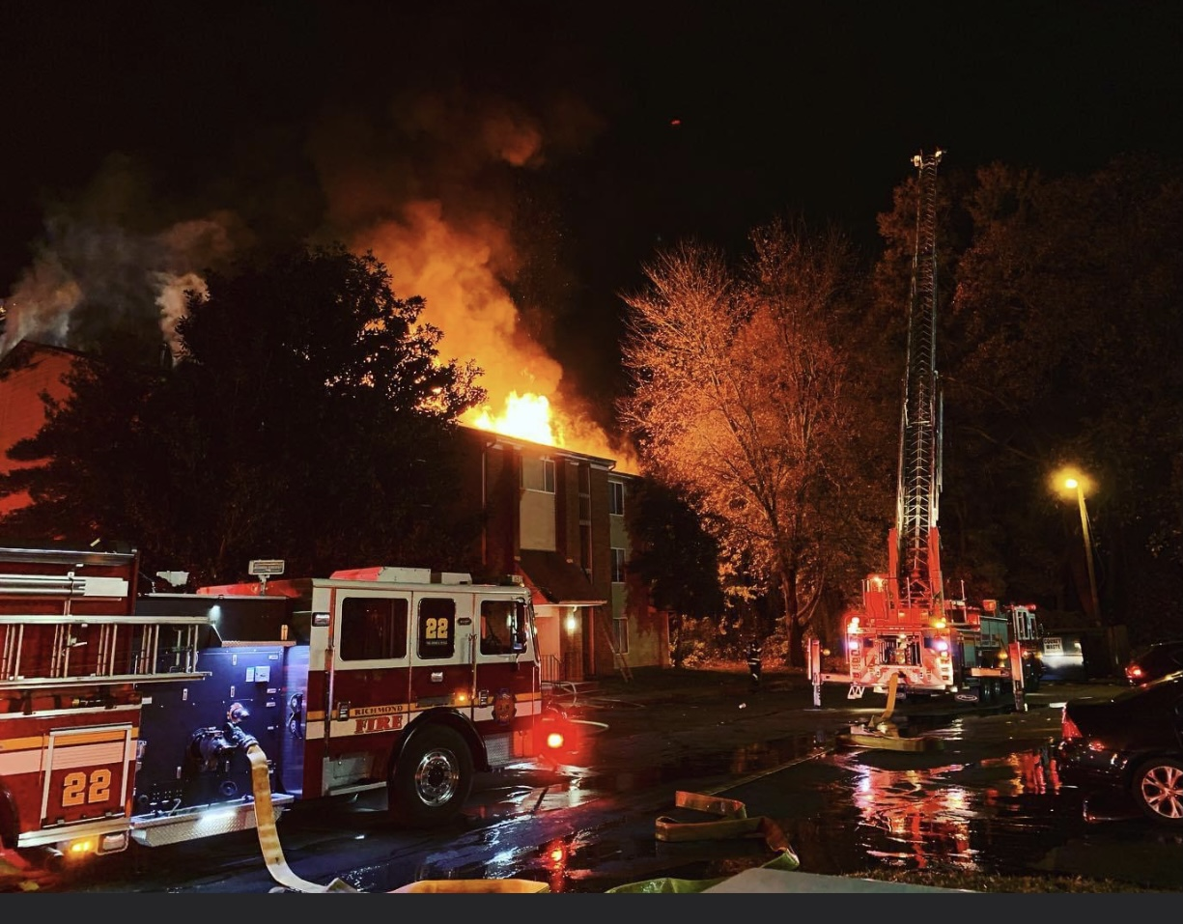

CONTENTS

From the Chief Office ………………………………………………………………………………………………. 3

Presidents Message ………………………………………………………………………………………………. 4

ANNUAL REPORT FOR 2021

YEAR OF SERVICE | EMERGENCY INCIDENTS
2021 | 212
2020 | 50
2019 | 30
2018 | 30
2017 | 20

Monthly Incidents
JAN | FEB | MAR | APR | MAY | JUN
4 | 10 | 11 | 15 | 11 | 16
JUL | AUG | SEP | OCT | NOV | DEC
16 | 29 | 15 | 27 | 31 | 27

INCIDENT TYPE | #
House fires | 70
Multi-family fires | 60
Commercial fires | 20
Water rescues | 17
Hazardous materials | 12
Utility incidents | 8
Train derailments | 2
Technical Rescues | 4
Vehicle fires near structure | 4
Vegetative fires | 1
Water leaks | 1
Structures damaged by high winds | 1
Assist Police SWAT | 3
Vehicles into structures | 3
Miscellaneous | 5
Motor vehicle accidents | 1

Working incidents | 1-Alarm | 2-Alarm | 3-Alarm
25 | 180 | 6 | 1

Average response time | 12 min 24 seconds
Average time spent per incident | 1 hour 2 min
Average # of members per incident | 2
Agencies Supported
City of Richmond | 191
Henrico County | 20
Goochland County | 1
Response by Apparatus
Rehab 1 | 148
Rehab 2 | Not in service
Rehab 3 | 10
Car 17 | 89
Most consecutive days with a response | 10 days 12/22 – 12/31
Most incidents in any day | Dec 4 (4 runs) Nov 2 (4 runs )

Emergency Incidents
Beavers | 15 | Heavener | 58 | Patrick | 0
Belcher | 4 | Heron | 0 | Pega | 2
Clark | 18 | Hyer | 1 | Renz | 39
Covert | 27 | Johnson * | 26 | Reynaud | 13
Dunn | 1 | Korb, G. | 1 | Riddell | 1
Fadley | 7 | Korb, S. | 144 | Rumberg | 0
Frasher | 1 | Meyenberg | 22 | Wade | 1
Garland | 4 | Motley | 2 | Wiley | 104
Haigler | 2 | Neiman | 4
*Former member
Service Points per member
Beavers | 97 | Heavener | 343 | Neiman | 47
Belcher | 23 | Heron | 6 | Patrick | 7
Clark | 285 | Herman | 6 | Pega | 35
Covert | 230 | Hyer | 88 | Renz | 224
Dunn | 162 | Johnson * | 149 | Reynaud | 175
Fadley | 40 | Korb, G. | 10 | Riddell | 52
Frasher | 5 | Korb, S. | 865 | Rumberg | 6
Garland | 223 | Meyenberg | 209 | Wade | 21
Haigler | 16 | Motley | 15 | Wiley | 587

Ina
Clark | 14 | Hyer | 17
Covert | 209 | Korb, S. | 783
Dunn | 13 | Meyenberg | 28
Fadley | 108 | Pega | 7
Garland | 24 | Renz | 200
Haigler | 24 | Reynaud | 33
Heavener | 272 | Wiley | 398
Heron | 3

Notable incidents
Incident 21-078 July 18, 2021 Time : 03:57
In the early morning hours, our Duty Officers phone rang with a call from the Richmond Fire Dispatcher. The dispatcher stated that the Incident Commander of a Henrico County two-alarm commercial fire had requested the support of our agency. This was the first time Henrico County had requested our support.
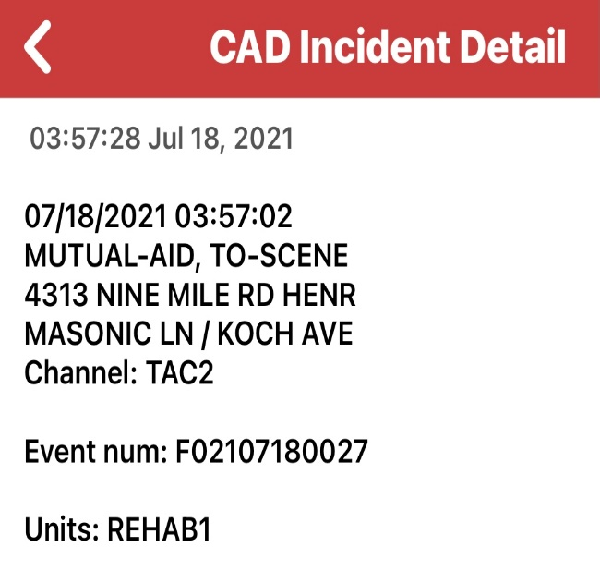
Within minutes our members were alerted and enroute to the incident. Members, Ken Clark, Mark Beavers and Steve Korb initiated their respective responses and first unit arrived in 17 minutes.
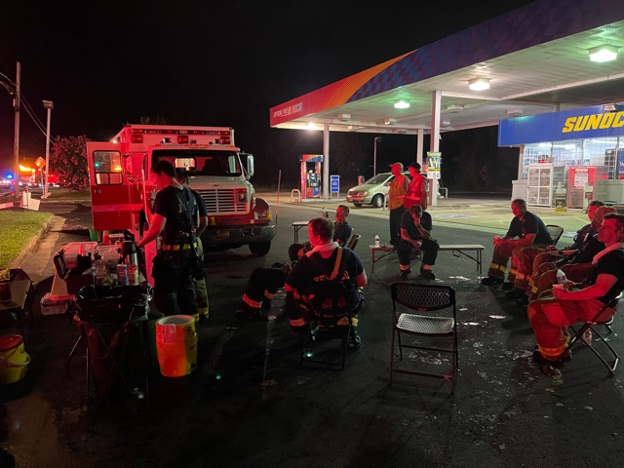

As the sun began to rise, Flying Squad members remained “open for service” and cleared the scene around 10 am that Sunday morning.
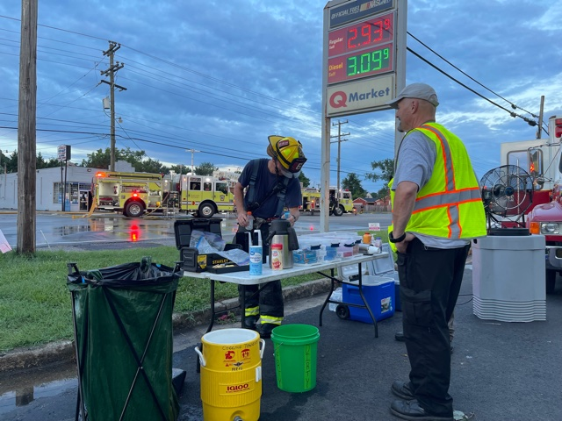

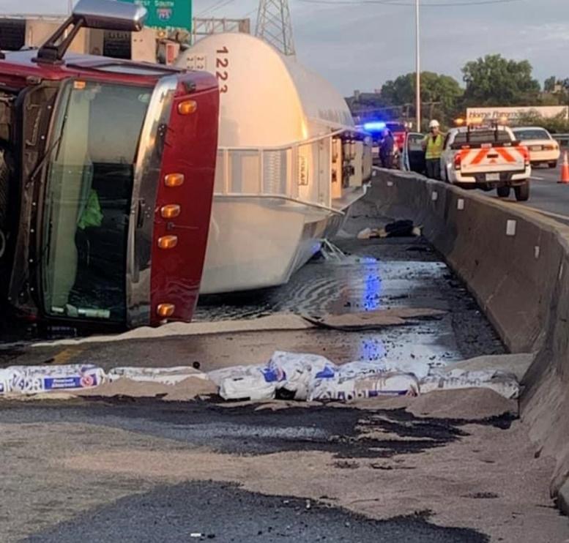
9/11/21
9000-gallon tanker truck leaking diesel fuel on Interstate 95
In the early morning hours of September 11th our crews were in the process of being briefed on the mornings 9/11 stair climb event at City Stadium. As the briefing began, Richmond began receiving calls of a tanker truck on it’s side in the southbound lanes of I-95.
The crew from Engine 5 reported the heavy smell of diesel fuel in the air as they departed their quarters on W. Leigh Street just south of I-95.
Several additional units were special called to this event including foam units, hazardous materials response and Virginia Emergency Management.
As our crews began to deploy for the scheduled stair climb we quickly deployed the necessary equipment and supplies to support that high demand event. The Incident Commander put in a “special call” for our resource. Flying Squad members divided up some necessary supplies and we deployed a crew to the incident within minutes of the special call. Our crew remained on scene for over 6 hours and Richmond Fire units were on scene for about 9 hours until the situation was mitigated.

On October 2nd the Goochland County Volunteer Fire-Rescue Association generously donated their 1987 Pierce Rescue Truck to our organization. We cannot express how grateful we are to their organization for the donation.
The vehicle will be placed into service in early 2022 as a front line Rehabilitative Response Apparatus. In addition to going in service the Flying Squad is happy to announce we will be entering into a Memorandum of Understanding to provide support to the firefighters in Goochland County.
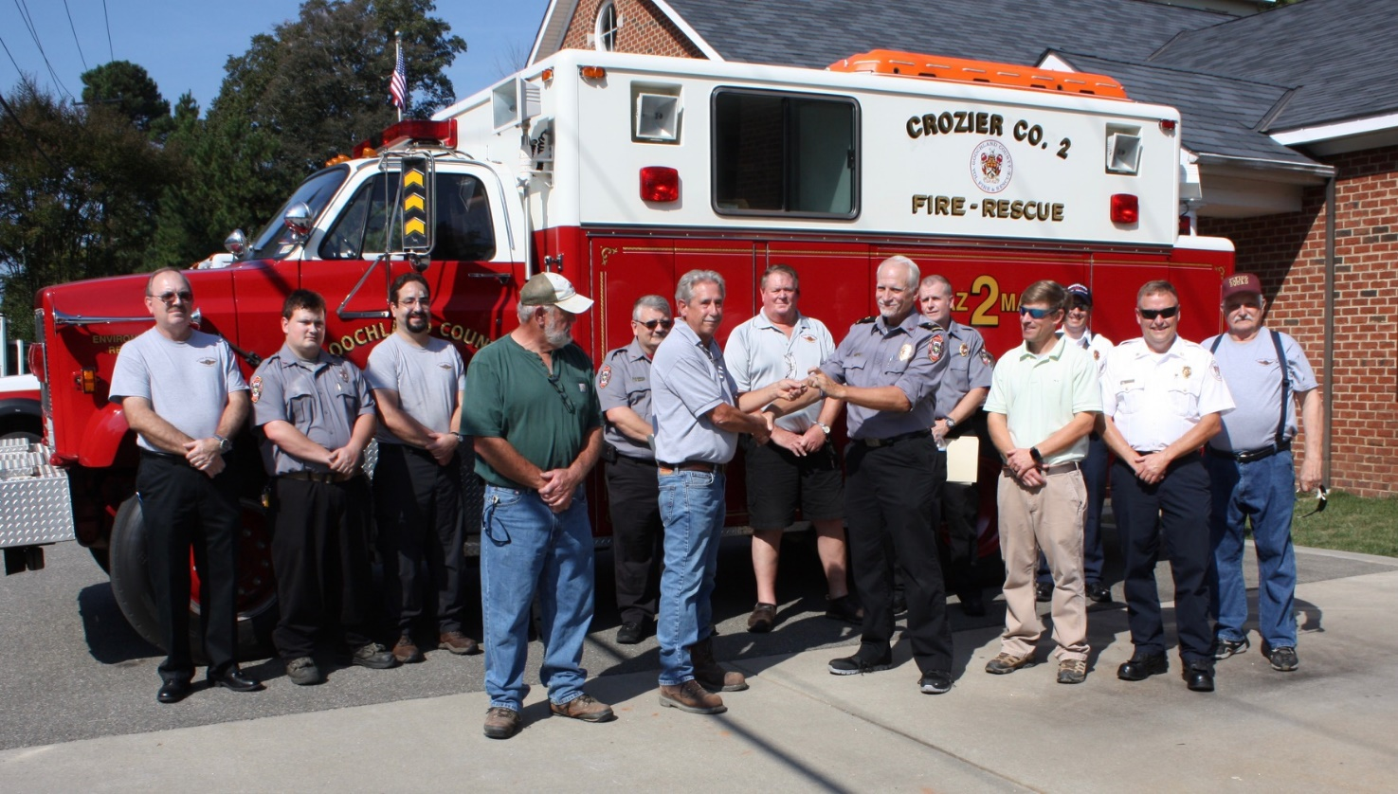

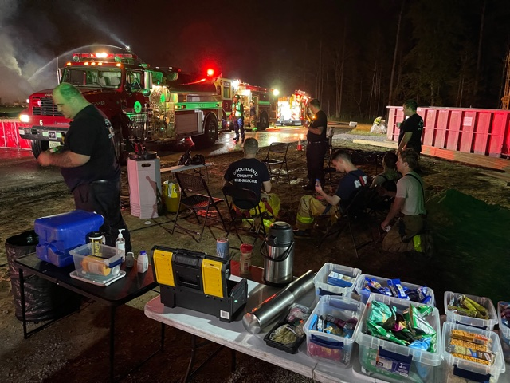
October 8th , 01:06 am (Goochland County)
In the early morning hours Goochland County arrived on scene to find an 8000 square foot house under construction fully involved in fire. Chief Ferguson put in a special call request to our organization. The Flying Squad received the call at 01:06 am.
Our Rehab unit along with our Car 17 Operator arrived on scene and began to establish a rehab area for this multi hour incident. Goochland County Firefighters were hydrated and provided an area to rest and recuperate. Snacks were given out to the hungry crews.
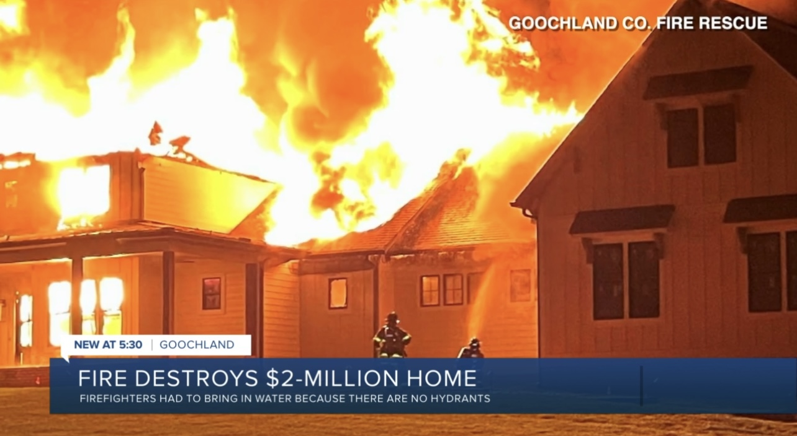

Incident 21-169
November 16th, 2021
At 05:19 am multiple 911 calls began coming into the Richmond Department of Emergency Communications reporting a fire in an apartment at 5004 Snead Road. First arriving units reported heavy fire showing. Within minutes a 2nd alarm was struck by Battalion 4 Incident Commander.
Flying Squad members began their response and access into the complex was limited due to multiple fire apparatus and civilian vehicles. The rehab supplies needed to be moved in on foot and a formal rehab area was setup in a grassy area
Multiple displaced residents were also supported throughout the incident. A GRTC bus was deployed to provide interior shelter during the cold morning.

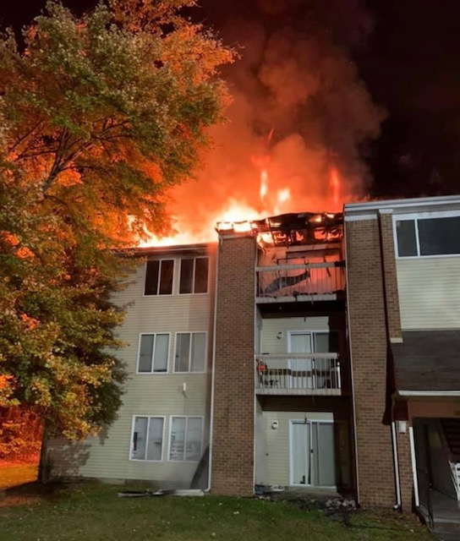

December 14th, 2021, The Henrico Firefighters Foundation Board presented us with a donation towards our operating costs. We truly appreciate this donation and will put it to good use to provide on scene rehabilitative support to the firefighters in Henrico County.
HENRICO COUNTY DIVISION OF FIRE INCIDENTS
DATE | RUN # | TIME | ADDRESS | TYPE
7/18/21 | 21-076 | 03:57 | 4313 Nine Mile Rd | 2-alarm commercial fire
8/30/21 | 21-111 | 15:07 | 4200 Balmoral Ave | Multi family structure fire
9/8/21 | 21-114 | 14:03 | 201 Westham Pkwy | House fire
10/9/21 | 21-138 | 12:10 | 9937 Mayland Drive | Hazardous Materials Response
10/11/21 | 21-142 | 20:39 | 2039 Clark Street | House fire
10/18/21 | 21-144 | 19:35 | 305 Williamsburg Rd | Commercial fire
10/21/21 | 21-148 | 00:16 | 9015 Horrigan Court | Multi family structure fire
10/29/21 | 21-153 | 06:13 | 8300 Kingsthorpe Ter | House fire
11/2/21 | 21-159 | 23:30 | 7905 Tamarino Drive | House fire
11/7/21 | 21-162 | 18:30 | 2130 Park Lane | House fire
11/11/21 | 21-165 | 03:48 | 13104 Carriage Pond Ct | House fire
11/17/21 | 21-170 | 05:43 | 1003 Old Williamsburg Rd | House fire
11/22/21 | 21-178 | 16:47 | 1303 Grumman Driver | House fire
11/28/21 | 21-182 | 15:55 | 2420 Pemberton Road | Skilled nursing facility
11/30/21 | 21-185 | 19:33 | 3600 Reynolds Rd | House fire
12/12/21 | 21-193 | 16:17 | 1614 Westcastle Drive | House fire
12/22/21 | 21-203 | 04:52 | 1600 Hollandale Drive | Commercial fire
12/24/21 | 21-205 | 09:26 | 2207 Buckingham Ave | House fire
12/25/21 | 21-206 | 13:56 | 6416 Engel Road | House fire
12/28/21 | 21-209 | 19:36 | 10356 Greenwood Road | House fire

